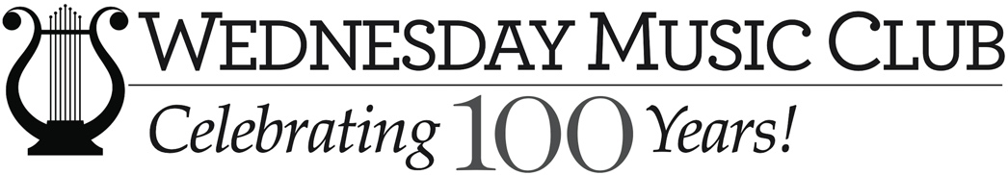

Dear Teacher Friends,
Welcome to this special 2023-2024 season of the Young Musicians’ Recitals! Our recitals will again be held in the spacious Hunter J. Smith Auditorium at The Center at Belvedere! Our hope is that you and your students will have a productive and enjoyable year and that participating in our recitals will be beneficial to you.
The recitals for this year are scheduled for Sunday afternoons at 1:30 p.m. on the following dates: October 23rd, January 29th, March 5th, and April 23rd.
Because we receive so many applications for our recitals, we must be firm about our application policies, which are as follows.
1. Applications for recitals are considered on a “first come, first served” basis. When we have received enough applications to fill a one-hour recital, we will place subsequent applications on our wait list, to be notified in case of cancellations.
2. There may be a maximum of two entries per teacher per recital; an entry may be either a solo or an ensemble. There may be only one piece per entry whether solo or ensemble. There should be no repeats played unless absolutely necessary and no piece may be longer than five minutes, unless cleared in advance with the Program Coordinator.
3. If a recital is not full, the Program Coordinator may decide to accept later applications, additional students per teacher, or longer pieces. You will be notified if this is the case.
Because the purpose of these recitals is not only to give the students an opportunity to play or sing before an audience but also to teach them performance manners, we ask that you prepare your students using the following guidelines:
1. Students should dress appropriately for a recital; just as soccer coaches expect their teams to wear their uniforms, we must teach students to wear concert attire.
2. Students should aim for polished performances. Memorization is strongly encouraged but not required; however, students should be able to play their pieces fluently and musically.
3. Students should bow to the audience before they play and again when they are finished. Please remind them that a bow is a musician’s way of acknowledging the audience’s applause and of saying, “Thank you for listening to me play today.”
4. Students should use original publications rather than copied music (a photocopy is allowed for eliminating a page turn). We need to teach respect for copyright laws.
5. Students and their families should stay for the entire recital and should be quiet and respectful of the other performers as well as the other audience members.
Family members and teachers are welcome to photograph the performances of their own children and students but not the performances of other recitalists.
We look forward to seeing you and your students this year!
Doris VanderMeulen
dvmeulen@gmail.com
Chair, Wednesday Music Club Recitals Committee

